William Otey

COMP 3700

Exam 2

Tasks:

Use Case 1

As a librarian, I want to add a new book to the database.

|  |  |
| --- | --- |
| User Action | System Reaction |
| 1. User enters correct Librarian login information | 2. System opens the “book info” screen |
| 3. User enters book name and author or barcode of book | 4. System checks if book exists. If the book does not exist, the system displays empty text fields for information. If the book exists, the system displays current info in text fields. |
| 5. User enters remaining information and click “save” button | 6. System stores input info and updates its external database |

As a User, I want to load a book

|  |  |
| --- | --- |
| User Action | System Reaction |
| 1. User enters correct Librarian login information | 2. System opens the “book info” screen |
| 3. User enters book name and author or barcode of book | 4. System checks if book exists. If the book does not exist, the system displays empty text fields for information. If the book exists, the system displays current info in text fields. |

Use Case 2

As a reader, I want to borrow a book.

|  |  |
| --- | --- |
| User Action | System Reaction |
| 1. User enters correct Reader login information | 2. System opens the “book borrowing” screen |
| 3. User enters book name and author or barcode of book and reader Id | 4. System checks if book exists. If the book does not exist, the system displays empty text fields for information. If the book exists, the system displays current info in text fields |
| 5. User chooses “borrow” | 6. System stores start and due date along with the readers name and updates its external database |

User Screens:

Entity Relationship diagram:

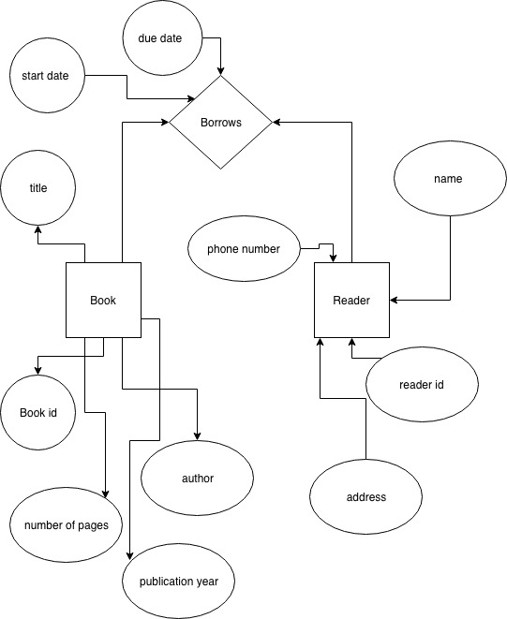

3. SQL Code:

CREATE TABLE Reader (

rName varchar(255) NOT NULL,

rID varchar(255) NOT NULL,

rAddress varchar(255) NOT NULL,

rphoneNumber varchar(255) NOT NULL,

PRIMARY KEY (rName)

);

CREATE TABLE Books (

book_ID varchar(255) NOT NULL,

book_title varchar(255) NOT NULL,

book_author varchar(255) NOT NULL,

number_of_pages int NOT NULL,

publication_year int NOT NULL,

PRIMARY KEY (book_ID)

);

CREATE TABLE Borrows (

borrow_ID varchar(255) NOT NULL,

reader_ID varchar(255) NOT NULL,

book_ID varchar(255) NOT NULL,

borrow_Date varchar(255) NOT NULL,

due_Date varchar(255) NOT NULL,

PRIMARY KEY (borrow_ID)

);

insert into Reader values ('William Otey', 'reader001', '100 Drury Lane', '555-1234');

insert into Books values ('book01','Book Title: Subtitle', 'Author: The Man ', 500 , 2019);

insert into Borrows values ('borrow01','reader001', 'book001', '01/01/2019', '01/15/2019db');

4. Java Code: Java Code is in the separate attachment.